INFS 1101 – Lab 13

Instructions

The lab consists of two parts:

* Part I consists of fundamental exercises: you need to complete, understand, and submit these exercises by midnight.
* Part II consists of additional exercises that you need to finish in the next **2 Days** and submit it.

For this lab, you will need to develop the flowchart and the code for each exercise. The flowchart should be developed with drawio, and the code should be developed in IDLE.

Make sure to include comments in each of your Python files indicating your name, student ID, course and section #, and name of the program.

Once you are done, put all your Python (.py) files and flowcharts in two zipped folders (**Lab11-part1.zip)** and (**Lab11-part2.zip)** , submit both parts in the same D2L dropbox.

Part I

## Exercise 1

Develop an algorithm called StudyHours that will achieve the following:

* Ask the user for the name.
* Ask the user for the number of hours they spent studying each week, during the past months.
* Validate the number of hours entered by the user that should be between 0 and 168 hours (total number of hours per week).
* The program should allow the user to enter as many months as he/she wants.
* The program should display the total hours spent studying during the previous months, and the overall average.
* **Hint**: the variables of your algorithm are highlighted in purple in the sample run.

#### Sample run 1:

**What is your name? Alex  
Do you want to enter data for a new month? (yes/no): yes  
--Entering data for Month 1--  
How many hours did you spend studying in week 1? 15  
How many hours did you spend studying in week 2? 20  
How many hours did you spend studying in week 3? 25  
How many hours did you spend studying in week 4? 30  
Do you want to enter data for another month? (yes/no): no  
Calculating total and average...  
Alex, the total hours you spent studying during these months is: 90 hours.  
The overall average per week is: 22.5 hours.**

**What is your name? Jordan  
Do you want to enter data for a new month? (yes/no): yes  
--Entering data for Month 1--  
How many hours did you spend studying in week 1? 170  
Invalid input! Please enter hours between 0 and 168.  
How many hours did you spend studying in week 1? 10  
How many hours did you spend studying in week 2? 12  
How many hours did you spend studying in week 3? 9  
How many hours did you spend studying in week 4? 0  
Do you want to enter data for another month? (yes/no): yes  
--Entering data for Month 2--  
How many hours did you spend studying in week 1? 15  
How many hours did you spend studying in week 2? 15  
How many hours did you spend studying in week 3? 10  
How many hours did you spend studying in week 4? 10  
Do you want to enter data for another month? (yes/no): no  
Calculating total and average...  
Jordan, the total hours you spent studying during these months is: 81 hours.  
The overall average per week is: 10.125 hours.**

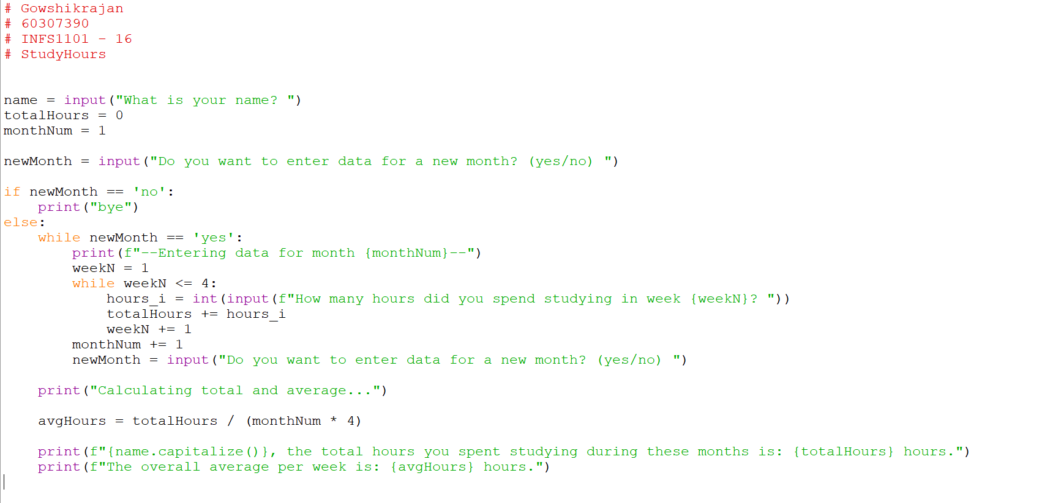

**Corrections in my code:**

* **avgHours = totalHours / (monthNum – 1) * 4**
* **hours_i = int(input(f”How many hours did you spend studying in week {weekN}”))**

**while 0 > hours_i or 168 < hours_i:**

**hours_i = int(input(f”How many hours did you spend studying in week {weekN}”))**

* **These have been fixed in exercise 2 and 3 and are already in flowchart.**

## Exercise 2

We will enhance the previous algorithm, after each week's input, the program should compare the current week's hours to the previous week's:

* If the current week has more hours, display an encouraging message about the increase.
* If the hours are the same, acknowledge the consistency.
* If the current week has fewer hours, display a motivational message to encourage more studying.
* **Hint**: the variables of your algorithm are highlighted in purple in the sample run.

#### Sample run 1:

**What is your name? Clara  
Do you want to enter data for a new month? (yes/no): yes  
--Entering data for Month 1--  
How many hours did you spend studying in week 1? 15  
Good effort, Clara!  
How many hours did you spend studying in week 2? 20  
Great job, Clara! You've increased your study hours!  
How many hours did you spend studying in week 3? 20  
Good consistency, Clara! Keep it up!  
How many hours did you spend studying in week 4? 25  
Great job, Clara! You've increased your study hours!  
Do you want to enter data for another month? (yes/no): yes  
--Entering data for Month 2--  
How many hours did you spend studying in week 1? 22  
Good effort, Clara!  
How many hours did you spend studying in week 2? 22  
Good consistency, Clara! Keep it up!  
How many hours did you spend studying in week 3? 18  
You've studied less this week compared to the last, Clara. Try to keep your hours up!  
How many hours did you spend studying in week 4? 20  
Great job, Clara! You've increased your study hours!  
Do you want to enter data for another month? (yes/no): no**

**Clara, the total hours you spent studying during these months is: 162 hours.  
The overall average per week is: 20.25 hours.**

Part II

## Exercise 3

We will enhance the algorithm even more, the program should return which month had the highest average and which one had the lowest average, and return the highest and lowest averages.

* **Hint**: the variables of your algorithm are highlighted in purple in the sample run.

#### Sample run 1:

**What is your name? Clara  
Do you want to enter data for a new month? (yes/no): yes  
--Entering data for Month 1--  
How many hours did you spend studying in week 1? 15  
Good effort, Clara!  
How many hours did you spend studying in week 2? 20  
Great job, Clara! You've increased your study hours!  
How many hours did you spend studying in week 3? 20  
Good consistency, Clara! Keep it up!  
How many hours did you spend studying in week 4? 25  
Great job, Clara! You've increased your study hours!  
Do you want to enter data for another month? (yes/no): yes  
--Entering data for Month 2--  
How many hours did you spend studying in week 1? 22  
Good effort, Clara!  
How many hours did you spend studying in week 2? 22  
Good consistency, Clara! Keep it up!  
How many hours did you spend studying in week 3? 18  
You've studied less this week compared to the last, Clara. Try to keep your hours up!  
How many hours did you spend studying in week 4? 20  
Nice Clara! You've increased your study hours from last week!  
Do you want to enter data for another month? (yes/no): no**

**Clara, the total hours you spent studying during these months is: 162 hours.  
The overall average per week is: 20.25 hours.**

**Clara, during these months, you studied the most in Month 2, with an average of 20.5 hours.**

**Your lowest study hours were in Month 1, with an average of 20 hours.**

